New Jersey’s Clean Energy Program™
Your Power to Save

Join the thousands of New Jersey homeowners, businesses and municipalities that have taken advantage of incentives offered by New Jersey's Clean Energy Program™. These programs provide opportunities for you to save energy, money and help protect our climate and shoreline. New Jersey’s Clean Energy Program strives to encourage and transform the way New Jersey consumes and manages its energy usage. Continue reading to learn more about how you can participate and watch your savings add up!

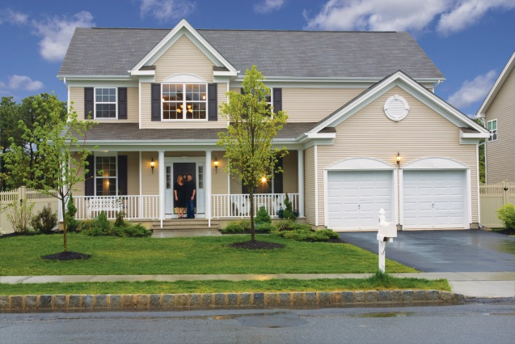
DOES YOUR HOME SUFFER FROM THE BLUES?
Did you know that spiders build their web in areas that have air flow?
Looking for subtle signs like spider webs could point to energy related issues within your home. Let a specially trained contractor review your home to identify ways to lower your energy bills. With incentives up to $4,000, the Home Performance with ENERGY STAR® program will make your home more comfortable, reduce your utility bill and check for any health and safety issues. Finding the webs is a first step; call a Home Performance with ENERGY STAR contractor today to check your home's health.
Read to see if one customer, Dianne, had spider webs!

A GUIDE TO A SELF-HOME ENERGY ASSESSMENT
If 'yes' is your answer to the following questions, it's time to consider making adjustments.
- Are your electric and/or gas bills too high?
- Do you wonder if your furnace or boiler or central AC may kick the bucket soon?
- Does your home keep you comfortable despite the seasonal conditions?
Knowing what questions to ask when evaluating what home improvements can be made is crucial as you prepare for the change in seasons. With the help of New Jersey's Clean Energy Program, we can be a guide in pointing out possible areas for improvements.

IT'S TIME
After a few erratic seasons of weather, you're finally convinced that it is now time to take action and replace a few things in the house. You've noticed that you can't buy a 60W bulb anymore and that there's more rust growing around the base of your water heater. Why contemplate about price points for equipment like a water heater and a washer and dryer when there are rebates!
Whether its spring or winter, any time of the year is a right time to replace a heating or cooling system.
If you’re looking for new bulbs, click to learn more about LED's and where you can purchase them at a low price!
To apply for your rebate online, click here

WHEN MOVING IS NOT YOUR ONLY OPTION
Whether you're in the process of designing your dream home or conceptualizing one, why not consider an ENERGY STAR Certified Home! These home designs that will help you save up to $400 annually on your utility bills.
With an ENERGY STAR Home the following benefits can be achieved:
- Higher resale value
- Building standards well above the rest!
- Wall to wall comfort and durability year round!
- Less energy use and overall savings

Learn more about how to build an ENERGY STAR ready Home!

OWN A BUSINESS?
Is it time to renovate or brighten up the place where you work? Why not suggest giving the lighting system a makeover. Not only will visibility be increased within the facility, but energy costs will decrease, which will allow dollars to be shifted to other costs. With up to 70% of the costs paid by New Jersey's Clean Energy Program, update the lighting, the HVAC and/or the refrigeration needs.
Discover all Direct Install has to offer! No matter the size or your energy use, there's a program for businesses of all sizes. Click here to learn more!

